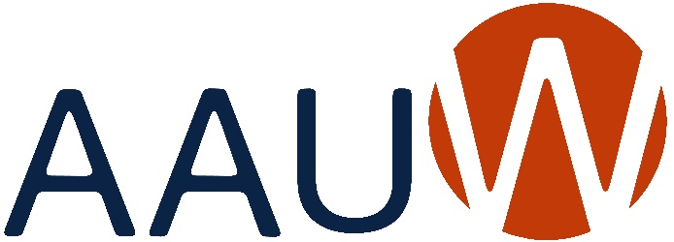
of Colorado

BRANCH ANNUAL REPORT 2023-2024
Due: May 31, 2024
Branch: | Colorado Springs
President: | Audrey McGuire & Brenda Wolfe | Date: May 31, 2024
Education & Training
Addressing the barriers and implicit biases that hinder advancement of women.
Goals: | What goals did your branch set this year that are in alignment with this macro area of National’s Strategic Plan? Please prioritize your list and indicate after each goal what the current status is (i.e. completed, % completed, estimated completion date, etc.).
- Increase awareness and success in STEM for middle school girls - COMPLETED
- Support educational equity at all education levels - COMPLETED

Programs: | Did you identify and/or hold any programs/activities/events that were in alignment with this macro area of National’s Strategic Plan? If yes, please give a brief description of each and the date in which it was held/conducted.
- STEM Day – Oct 19, 2023 – Hosted a STEM Day for 150 seventh grade girls which included hands-on experiments with Leads from science fields and a STEM Keynote. Over 60% of participants are on free or reduced lunch programs.
- Public Policy Branch Program – Jan 20, 2024 – Reaching for Digital Equity. Panel discussion.
Economic Security
Ensuring livelihoods for women.
Goals: | What goals did your branch set this year that are in alignment with this macro area of National’s Strategic Plan? Please prioritize your list and indicate after each goal what the current status is (i.e. completed, % completed, estimated completion date, etc.).
- Support women with their educational goals and future economic security by awarding college scholarships - COMPLETED
- Help expand career development awareness – only 15% of financial advisers are women. COMPLETED
Programs: | Did you identify and/or hold any programs/activities/events that were in alignment with this macro area of National’s Strategic Plan? If yes, please give a brief description of each and the date in which it was held/conducted.
- Awarded 8 local scholarships at $2000 each. Recognition during Welcome Coffee in Sept. 2023 and fundraising through our Author’s day and Silent Auction in June 2024.
- Environmental Action IG hosted a branch meeting which featured a panel discussion on: Socially Responsible Investing: Doing Well While Doing Good.
Leadership
Closing the gender gap in leadership opportunities.
Goals: | What goals did your branch set this year that are in alignment with this macro area of National’s Strategic Plan? Please prioritize your list and indicate after each goal what the current status is (i.e. completed, % completed, estimated completion date, etc.).
- Keep the Branch focused on inclusive pathways within our Branch. COMPLETED
- Promote the benefits gained from experiencing leadership within the safe confines of AAUW. COMPLETED
- Host the State Convention with its theme of Women in Leadership: Barriers and Biases. COMPLETED
Programs: | Did you identify and/or hold any programs/activities/events that were in alignment with this macro area of National’s Strategic Plan? If yes, please give a brief description of each and the date in which it was held/conducted.
- Held a Branch meeting on Feb 17, 2024 to promote awareness of our LBGTQ IA2+ community. Panel from diverse organizations who are members and allies with in the community.
- Colorado Women’s Hall of Fame – If you can see it – you can be it! Program on April 13, 2024.
- Recognized our Branch Leaders, past and present, on April 13, 2024 when we Celebrated our Stars. Nominating committee provided a full slate of officers for next year.
Governance & Sustainability
Ensuring the strength, relevance, and viability of AAUW well into the future.
Goals: | What goals did your branch set this year that are in alignment with this macro area of National’s Strategic Plan? Please prioritize your list and indicate after each goal what the current status is (i.e. completed, % completed, estimated completion date, etc.).
- Achieve recognition as a Five Star Branch – 66% Complete.
- Awareness for AAUW Funds through the Names Honored Award - COMPLETED
- Achieve greater impact through partnerships in the Community: COMPLETED
Programs: | Did you identify and/or hold any programs/activities/events that were in alignment with this macro area of National’s Strategic Plan? If yes, please give a brief description of each and the date in which it was held/conducted.
- Achieved recognition as a 3-star branch.
- Contributions to AAUW Funds : $2500
- Visibility through: International Women’s Day co-sponsor (March); Pikes Peak Women collaboration and supporter of their event, Wine, Women and Chocolate (February); building philanthropy connections through the Pikes Peak Community Fund events.
- Strong participation in our 22 Interest Groups within the Branch.

Send a copy of this report to
Joan Brown, AAUW of Colorado President
At enneajoan@gmail.com
And to
Scott Brown (boomer 19@gmail.com) for Colorado Website

