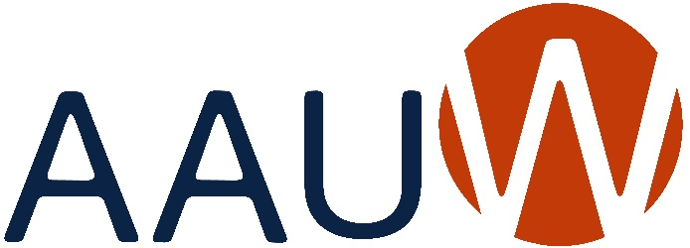
of Colorado

BRANCH ANNUAL REPORT 2023-2024
Due: May 31, 2024
Branch: | Lakewood
President: | Gail Hoffman and Pam Lacy | Date: 5/30/24
 | Co-Presidents
Education & Training
Addressing the barriers and implicit biases that hinder advancement of women.
Goals: | What goals did your branch set this year that are in alignment with this macro area of National’s Strategic Plan? Please prioritize your list and indicate after each goal what the current status is (i.e. completed, % completed, estimated completion date, etc.).
We promoted education in our newsletter and in our programming. We discussed ways that gender biases affect us and promoted non-profits that help women including Safe House, Mi Casa and The Women’s Bean Project.

Programs: | Did you identify and/or hold any programs/activities/events that were in alignment with this macro area of National’s Strategic Plan? If yes, please give a brief description of each and the date in which it was held/conducted.
We held a public Policy forum in October with Jefferson County School Board candidates. Many of s attended the virtual Public Policy Day which Focused on Education and changes which will affect gender equity.

Economic Security
Ensuring livelihoods for women.
Goals: | What goals did your branch set this year that are in alignment with this macro area of National’s Strategic Plan? Please prioritize your list and indicate after each goal what the current status is (i.e. completed, % completed, estimated completion date, etc.).
Our Goal is to become involved with the STEM Program at Alameda International Jr/Sr High School.
Programs: | Did you identify and/or hold any programs/activities/events that were in alignment with this macro area of National’s Strategic Plan? If yes, please give a brief description of each and the date in which it was held/conducted.
We prepared a Eugenia McClure Grant Application that was awarded for enhanced science curriculum. We funded transportation and were to send several chaperones on a field trip for 80 7th graders to attend a career day at MSU sponsored by the American Society of Women Engineers. The trip was canceled due to protests on campus.
Leadership
Closing the gender gap in leadership opportunities.
Goals: | What goals did your branch set this year that are in alignment with this macro area of National’s Strategic Plan? Please prioritize your list and indicate after each goal what the current status is (i.e. completed, % completed, estimated completion date, etc.).
We encourage mentoring as a way of continuing to be involved in promoting leadership for younger women. Next year our goal is to participate in Career Day at Alameda International Jr/Sr High School as part of the STEM Program.
Programs: | Did you identify and/or hold any programs/activities/events that were in alignment with this macro area of National’s Strategic Plan? If yes, please give a brief description of each and the date in which it was held/conducted.
We have held several meetings to promote continued and expanded volunteer opportunities with Alameda Jr/Sr High School’s STEM Program and Career Day. We have a Scholarship fundraiser in June and work with Red Rocks Community College to award a $2500 scholarship in August. We sponsored the Jefferson County Good News Breakfast in April and collected monthly donations for the Action Center, where several members volunteer. Many members adopt a family at Christmas as well.
Governance & Sustainability
Ensuring the strength, relevance, and viability of AAUW well into the future.
Goals: | What goals did your branch set this year that are in alignment with this macro area of National’s Strategic Plan? Please prioritize your list and indicate after each goal what the current status is (i.e. completed, % completed, estimated completion date, etc.).
We support AAUW’s National agenda including: NCCWSL Scholarships, promote webinars and the Women’s Economic Empowerment Initiative on the national website.
Programs: | Did you identify and/or hold any programs/activities/events that were in alignment with this macro area of National’s Strategic Plan? If yes, please give a brief description of each and the date in which it was held/conducted.
Our Branch newsletter encouraged all members to vote in the election regarding membership qualifications in May. We support recruiting new members and welcomed our scholarship recipient and 3 new members this year. Our membership has fallen to 87, 14 have been in our Branch for 5 years and 3 are lifetime members.

Send a copy of this report to
Joan Brown, AAUW of Colorado President
At enneajoan@gmail.com
And to
Scott Brown (boomer 19@gmail.com) for Colorado Website

