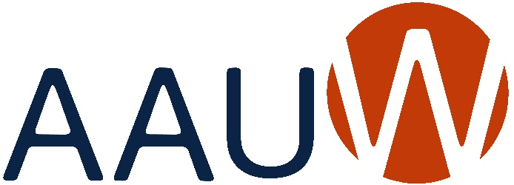
of Colorado

BRANCH ANNUAL REPORT 2022-2023
Due: May 31, 2023
Branch: | Lakewood, Colorado
President: |  | Date: | 5/31/2023
Co-Presidents | Pamela Lacy
 | Pat Wakham
Education & Training
Addressing the barriers and implicit biases that hinder advancement of women.
Goals: | What goals did your branch set this year that are in alignment with this macro area of National’s Strategic Plan? Please prioritize your list and indicate after each goal what the current status is (i.e. completed, % completed, estimated completion date, etc.).
We support ballot issues and legislation in Colorado to promote the support of women and families in the workforce. Paid Family leave has now been passed and we support legislation that gives funding for women’s health and reproductive health care as well as protections for domestic violence and human trafficking.

Programs: | Did you identify and/or hold any programs/activities/events that were in alignment with this macro area of National’s Strategic Plan? If yes, please give a brief description of each and the date in which it was held/conducted.
In September our monthly meeting was held at the Jefferson County Bel Mar Library. Our librarian gave us an overview of the many resources available and plans for future expansion.

Economic Security
Ensuring livelihoods for women.
Goals: | What goals did your branch set this year that are in alignment with this macro area of National’s Strategic Plan? Please prioritize your list and indicate after each goal what the current status is (i.e. completed, % completed, estimated completion date, etc.).
Lakewood Branch currently has established a scholarship program with fundraising annually.
Programs: | Did you identify and/or hold any programs/activities/events that were in alignment with this macro area of National’s Strategic Plan? If yes, please give a brief description of each and the date in which it was held/conducted.
Our Branch encourages community volunteerism and also support of the Action Center, our local nonprofit that has a food bank, clothing and many support services for low income families.
Leadership
Closing the gender gap in leadership opportunities.
Goals: | What goals did your branch set this year that are in alignment with this macro area of National’s Strategic Plan? Please prioritize your list and indicate after each goal what the current status is (i.e. completed, % completed, estimated completion date, etc.).
Lakewood has set no specific goals in this area, however, we are identifying opportunities to partner with STEM projects, and we have identified potential partners.
Programs: | Did you identify and/or hold any programs/activities/events that were in alignment with this macro area of National’s Strategic Plan? If yes, please give a brief description of each and the date in which it was held/conducted.
We participated in Colorado Women’s Day and Women Powering Change to gain ideas for projects. We educate our members regarding International Women’s Day and the # Me Too Movement.
Governance & Sustainability
Ensuring the strength, relevance, and viability of AAUW well into the future.
Goals: | What goals did your branch set this year that are in alignment with this macro area of National’s Strategic Plan? Please prioritize your list and indicate after each goal what the current status is (i.e. completed, % completed, estimated completion date, etc.).
Our goal is to continue the existence and viability of the Lakewood Branch through retaining members, recognition and recruitment.
Programs: | Did you identify and/or hold any programs/activities/events that were in alignment with this macro area of National’s Strategic Plan? If yes, please give a brief description of each and the date in which it was held/conducted.
Retention: We reach out to current members, many of whom no longer attend meetings, and we encourage them to continue their membership which supports National AAUW. Recognition: We recognize our members if they have a milestone birthday and we recognize those who have supported us long-term. Recruitment: We have brainstormed how to recruit and retain new members, but this has been particularly difficult during the last three years during COVID.
Our Branch has a stellar record in members giving to National outside of their dues participation, and our branch gives generously to the AAUUW Fund and NCCWSL Scholarships.
DEIS: We held a meeting ths Spring which focused on diversity and inclusion which opened us up to the many ways diversity is expressed, even within our branch. This interactive meeting was well received by all.

Send a copy of this report to
Joan Brown, AAUW of Colorado President
At enneajoan@gmail.com
And to
Scott Brown (boomer 19@gmail.com) for Colorado Website

