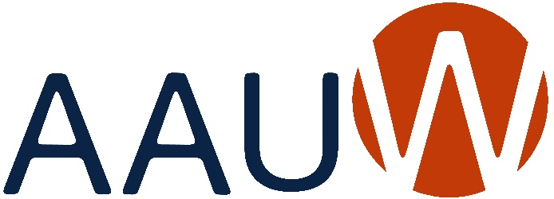
of Colorado

BRANCH ANNUAL REPORT 2022-2023
Due: May 31, 2023
Branch: | Durango
President: | None | Date: 6/16/23
Education & Training
Addressing the barriers and implicit biases that hinder advancement of women.
Goals: | What goals did your branch set this year that are in alignment with this macro area of National’s Strategic Plan? Please prioritize your list and indicate after each goal what the current status is (i.e. completed, % completed, estimated completion date, etc.).
Programs: | Did you identify and/or hold any programs/activities/events that were in alignment with this macro area of National’s Strategic Plan? If yes, please give a brief description of each and the date in which it was held/conducted.
October 2022: guest speaker Dr. Sarah Roberts-Cady “Rethinking the Debate About Abortion”
February 2023: zoomed with author Lynne Bryant – her books are based on history of the South
March 2023 Theme: “Celebrating Women Who Tell Our Stories” for Women’s History Month.
Our own branch member Judith Reynolds won the Extraordinary Woman Award
presented by the Women’s Resource Center at their March fundraiser. At that event, a
branch member was able to give a 10 minute summary of AAUW’s goals, which resulted
in future collaborations with the WRC.
Also during this month, four members of our Memories Group were invited to read their
stories at an event sponsored by the Professional Women’s Network.
May 2023: Our Book and Author Scholarship Fundraiser had two very different authors. Dr. Ana Maria Diaz Collazos from Columbia writes children’s books in Spanish. Dr. Janet L. Jones wrote “Horse Brain/Human Brain.”
In addition, our Walk and Talk interest group visited The Southern Ute Cultural Center, the Aztec Ruins, the Center for Southwest Studies at FLC, the Animas Museum for Women’s History Month and Rosie the Riveter Day, among other learning adventures.
Economic Security
Ensuring livelihoods for women.
Goals: | What goals did your branch set this year that are in alignment with this macro area of National’s Strategic Plan? Please prioritize your list and indicate after each goal what the current status is (i.e. completed, % completed, estimated completion date, etc.).
Programs: | Did you identify and/or hold any programs/activities/events that were in alignment with this macro area of National’s Strategic Plan? If yes, please give a brief description of each and the date in which it was held/conducted.
The Durango Branch is partnering with the Grub Hub on the Fort Lewis Campus which provides clothing, food, women’s supplies and housing to those students who are in need. One of our members housed a student this semester through this program. The director of this program will be our guest speaker at our welcome coffee in September.
December 2022: Holiday Open House – collected food for the Durango Food Bank
Leadership
Closing the gender gap in leadership opportunities.
Goals: | What goals did your branch set this year that are in alignment with this macro area of National’s Strategic Plan? Please prioritize your list and indicate after each goal what the current status is (i.e. completed, % completed, estimated completion date, etc.).
Programs: | Did you identify and/or hold any programs/activities/events that were in alignment with this macro area of National’s Strategic Plan? If yes, please give a brief description of each and the date in which it was held/conducted.
The Durango Branch in collaboration with Fort Lewis College has three young women who will attend NCCWSL this year. The branch is providing full transportation for two of those students.
The branch also awarded three scholarships this year and is fundraising for a fourth.
Governance & Sustainability
Ensuring the strength, relevance, and viability of AAUW well into the future.
Goals: | What goals did your branch set this year that are in alignment with this macro area of National’s Strategic Plan? Please prioritize your list and indicate after each goal what the current status is (i.e. completed, % completed, estimated completion date, etc.).
Programs: | Did you identify and/or hold any programs/activities/events that were in alignment with this macro area of National’s Strategic Plan? If yes, please give a brief description of each and the date in which it was held/conducted.
Our newest board members saw a need for more interaction among our members and suggested adding activities to our calendar that would encourage that. Also, we added two new interest groups to the three that had long been the only ones.
We also are in the process of collaborating activities with the Women’s Resource Center, which several of our members already belong to.

Send a copy of this report to
Joan Brown, AAUW of Colorado President
At enneajoan@gmail.com
And to
Scott Brown (boomer 19@gmail.com) for Colorado Website

