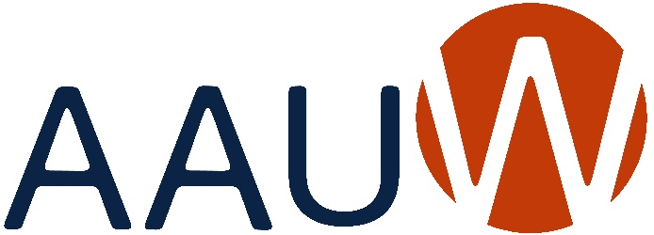
of Colorado

BOARD ANNUAL REPORT 2021-2022
Due: April 20, 2022
Office / Committee:
Name: Date:
STRATEGIC PLAN AREAS

Education & Training: Addressing the barriers and implicit biases that hinder advancement of women.
Economic Security: Ensuring livelihoods for women.
Leadership: Closing the gender gap in leadership opportunities.
Governance & Sustainability: Ensuring the strength, relevance, and viability of AAUW well into the future.
Goals: What goals did you set this year that are in alignment with this Strategic Plan? Please prioritize your list and indicate after each goal what the current status is (i.e., completed, % completed, estimated completion date, etc.).
Programs: Did you identify and/or hold any programs/activities/events that were in alignment with this Strategic Plan? If yes, please give a brief description of each and the date on which it was held/conducted.

Send a copy of this report to
Joan Brown, AAUW of Colorado President
At enneajoan@gmail.com
And to
Kathy Hall, Webmaster
bknp@comcast.net

