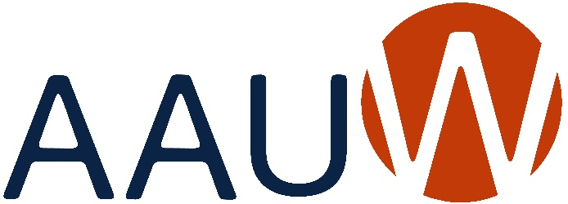
of Colorado

BRANCH ANNUAL REPORT 2021-2022
Due: May 31, 2022
Branch:
President: |  | Date:
Education & Training
Addressing the barriers and implicit biases that hinder advancement of women.
Goals: | What goals did your branch set this year that are in alignment with this macro area of National’s Strategic Plan? Please prioritize your list and indicate after each goal what the current status is (i.e. completed, % completed, estimated completion date, etc.).
Programs: | Did you identify and/or hold any programs/activities/events that were in alignment with this macro area of National’s Strategic Plan? If yes, please give a brief description of each and the date in which it was held/conducted.
Economic Security
Ensuring livelihoods for women.
Goals: | What goals did your branch set this year that are in alignment with this macro area of National’s Strategic Plan? Please prioritize your list and indicate after each goal what the current status is (i.e. completed, % completed, estimated completion date, etc.).
Programs: | Did you identify and/or hold any programs/activities/events that were in alignment with this macro area of National’s Strategic Plan? If yes, please give a brief description of each and the date in which it was held/conducted.
Leadership
Closing the gender gap in leadership opportunities.
Goals: | What goals did your branch set this year that are in alignment with this macro area of National’s Strategic Plan? Please prioritize your list and indicate after each goal what the current status is (i.e. completed, % completed, estimated completion date, etc.).
Programs: | Did you identify and/or hold any programs/activities/events that were in alignment with this macro area of National’s Strategic Plan? If yes, please give a brief description of each and the date in which it was held/conducted.
Governance & Sustainability
Ensuring the strength, relevance, and viability of AAUW well into the future.
Goals: | What goals did your branch set this year that are in alignment with this macro area of National’s Strategic Plan? Please prioritize your list and indicate after each goal what the current status is (i.e. completed, % completed, estimated completion date, etc.).
Programs: | Did you identify and/or hold any programs/activities/events that were in alignment with this macro area of National’s Strategic Plan? If yes, please give a brief description of each and the date in which it was held/conducted.

Send a copy of this report to
Joan Brown, AAUW of Colorado President
at enneajoan@gmail.com
and to
Kathy Hall, Webmaster
bknp@comcast.net

